<https://www.youtube.com/watch?v=mCq8-xTH7jA&list=PLzdnOPI1iJNcsRwJhvksEo1tJqjIqWbN-&index=2&ab_channel=Code.org>

This video is a basic overview of what makes a computer a computer.

The ALU functions as the mathematical brain of a computer.

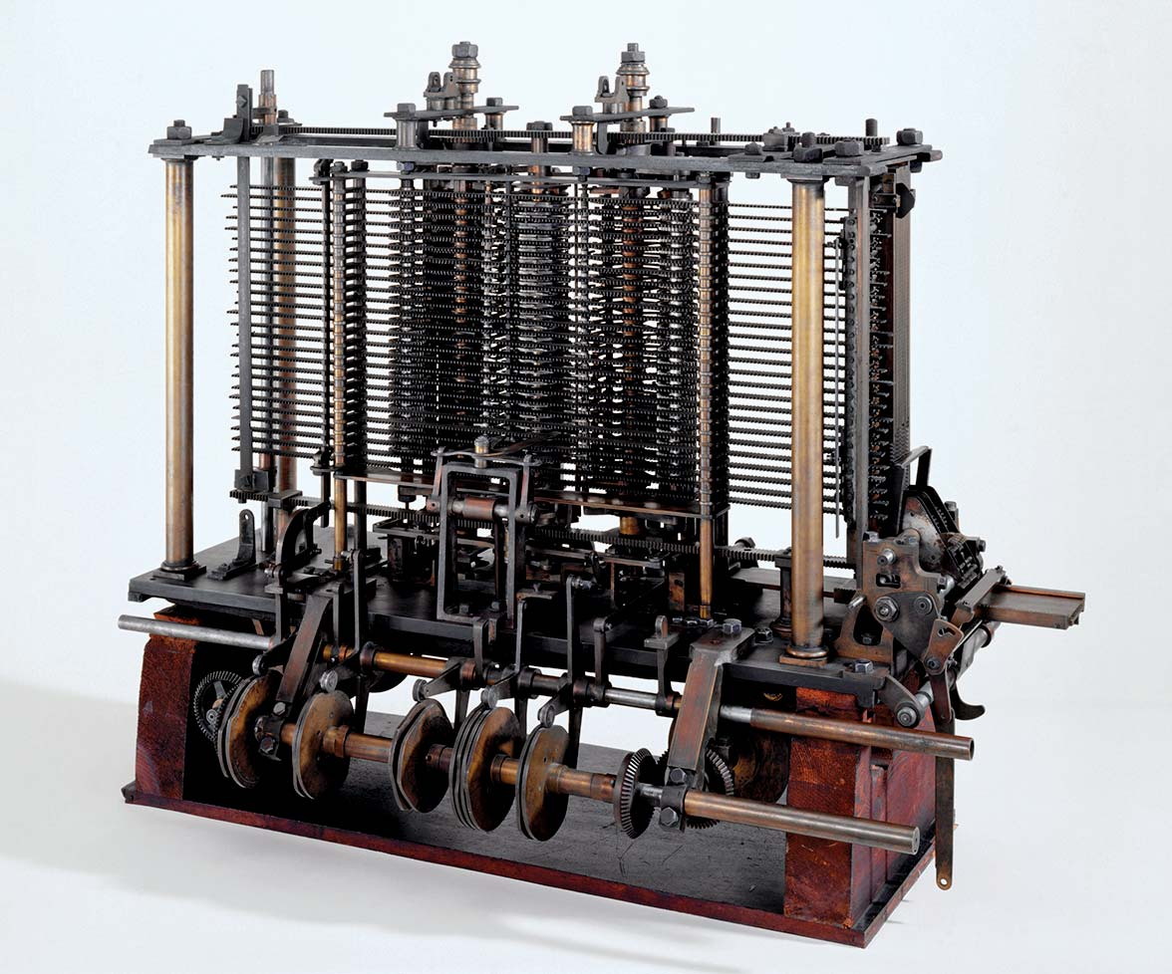

The Analytical engine is generally considered the first computer built by Charles Babbage, who worked on it until his death in 1871. He generalized the operation of his difference engine so it could perform other forms of calculations.

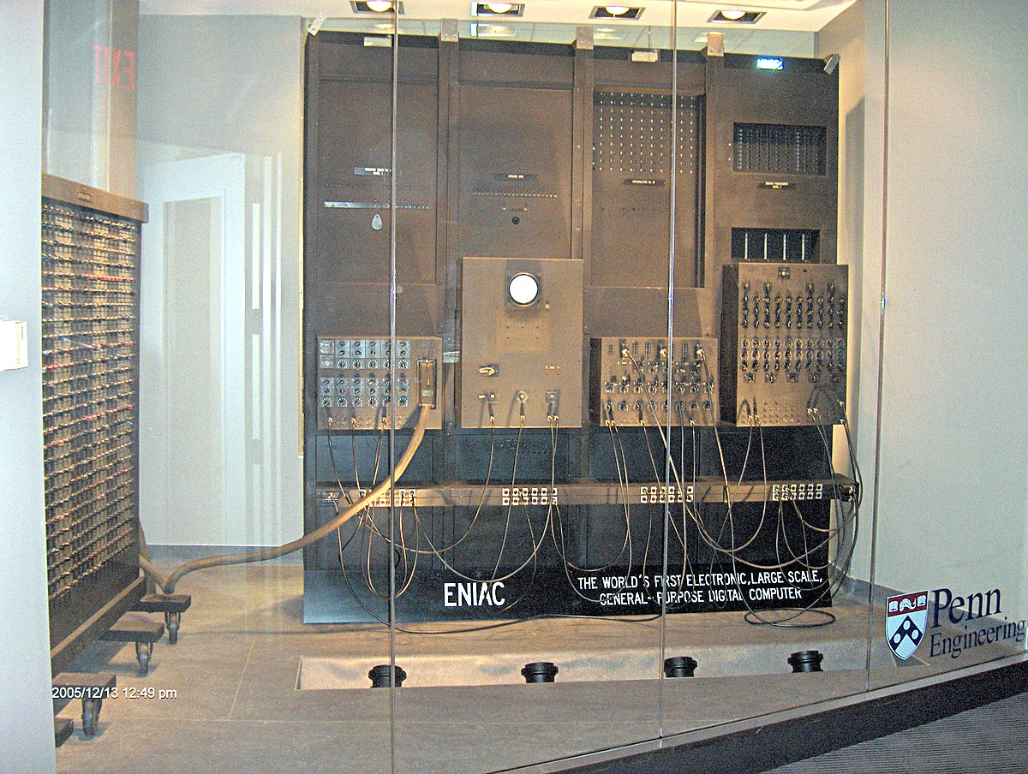

ENIAC (Electronic Numerical Integrator and Computer) was the first programmable, electronic, general-purpose digital computer.